**Part 1**

“The best way to predict the future is to invent it.”   
 – Alan Kay, 1971. Xerox PARC researchers’ maxim.

Think about your professional destination after you complete your work here at Seneca: where would you like to go next? What skills and knowledge are you going to need? What will happen between now and then? Consider your [ikigai](https://www.forbes.com/sites/chrismyers/2018/02/23/how-to-find-your-ikigai-and-transform-your-outlook-on-life-and-business/#2896b8ba2ed4). (“eye-ki-guy”)

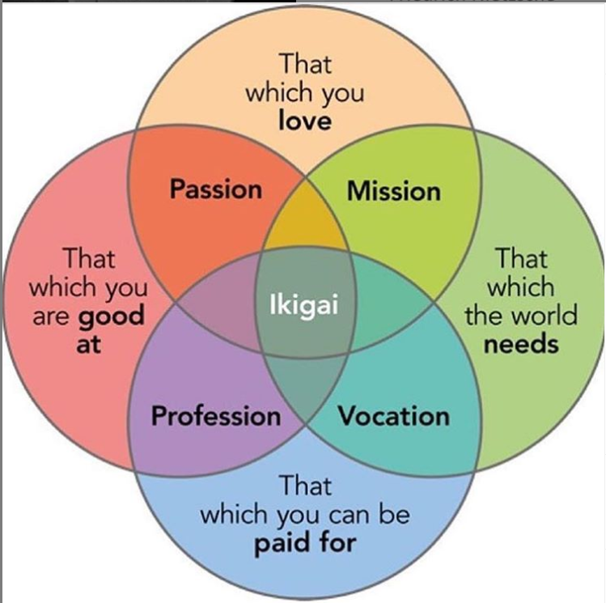

If you are not sure about the future – and who is? – this might help:

The [Future of Jobs report](http://www3.weforum.org/docs/WEF_Future_of_Jobs_2018.pdf) by the [World Economic Forum](https://www.weforum.org/reports/the-future-of-jobs-report-2018)

* Summary: [5 things to know about the future of jobs](https://www.weforum.org/agenda/2018/09/future-of-jobs-2018-things-to-know/)
* [Opportunities](https://www.weforum.org/agenda/2019/01/jobs-of-next-20-years-how-to-prepare/) in the next 20 years
* [Information & Communication Technologies](http://reports.weforum.org/future-of-jobs-2018/information-communication-technologies/)

🡺 Write your future history and/or make a list. (~250 words in all) Keep a copy for your future self.

As I continue my education at Seneca College, I will try to get exposed to various programming languages, study and implement many different algorithms and data structures, work on how computer system works, and learn whatever there is for me.

My ultimate goal is to be a console game developer since I love playing games and it is a lucrative industry. But first I will start off as a web developer after college and then try to learn the basics of game programming to achieve my ultimate objective. And I want to get to the point where I can effectively communicate in English as soon as possible. Through taking math and science courses such as discrete mathematics, I will learn the laws of physics and mathematical application and implement them while programming.

Coding is an extremely creative and entertaining process in which I can simply type in appropriate words, and they appear in reality. All parts of coding including debugging and thinking logically seem to be entertaining to me so far. As I learn more of coding at Seneca, I will be honored to grasp the idea of programming and enjoy the beauty of coding.

**Part 2**

Investigate four **different** topics that you are interested in or one of the many things CP4P will cover.

Report on a news item (new to you, it does not have to be recent news). Use the format below.

Length should be 150 to 200 words for each of the four news items, three to five sentences for each of parts b, c, d.

1. ICT news, tutorial, or CP4P course topic: _Canada’s cyber-cops- four stories about what they really do.__
   1. News or tutorial item’s URL: <https://www.itworldcanada.com/article/canadas-cyber-cops-four-stories-of-what-they-really-do/426115>
   2. News or tutorial item Summary:

🡪

It is written about what the Canadian Cyber Police do and what people apply for it. In fact, one example of a criminal investigation shows how cyber police use computers. And prospects of cyber Coordinating Unit to catch cybercrime organizations.

* 1. Why did you choose that topic? What interests you about it?

🡪

I was wondering what kind of job I have by graduating from Computer Programming Department, and I think it is very attractive that I can work as a programmer for a country, not a company.

* 1. Why did you find that news/tutorial item of value?

🡪

This article judge it was worth it because it gave me a very specific explanation about cyber police. It was also more reliable because it told real-world stories from the reality of cyber cops.

1. ICT news, tutorial, or CP4P course topic:

_Students, educators and parents struggling to adapt to new learning dynamic._

* 1. News or tutorial item’s URL:

<https://www.itworldcanada.com/article/students-educators-and-parents-struggling-to-adapt-to-new-learning-dynamic/430310>

* 1. News or tutorial item Summary:

🡪

Education of Canada has been paralyzed by coronavirus pandemics.

Almost all education institutions have conducted classes online and explain what happened this summer. Regardless of how interactive online learning sessions can be, a virtual classroom is no substitute for in-person teaching.

* 1. Why did you choose that topic? What interests you about it?

🡪

I chose this article because I am in the same situation and I cannot enter Canada and am currently taking foreign university classes only through online lectures in my country. I felt a lot of empathy, and by reading this article, I can understand what I can do what I should be careful about at the same time as I take the lecture.

* 1. Why did you find that news/tutorial item of value?

🡪Many of the results of what happened last semester already written in this article, and many interviews and examples of students were included, so I thought it would be valuable .

1. ICT news, tutorial, or CP4P course topic: ___Managing your Career as a Developer._______
   1. News or tutorial item’s URL: <https://www.linkedin.com/learning/paths/managing-your-career-as-a-developer?u=2169170>
   2. News or tutorial item Summary:

🡪

There are eight courses for learning how to own my career and be successful in the job. It explains how to write a resume, get a interview successfully, and have good communication skills. Especially, learn about the skills and tools what I need to get a job as a front-end, back-end, or full-stack web developer.

* 1. Why did you choose that topic? What interests you about it?

🡪

I chose this course because my goal Is not just to have a general understanding of my computer major and to get a successful job, but to just graduate from this college. Also, the culture where I am and where I am being educated are very different, I think I can organize the table of contents about my future by looking at these things in advance.

* 1. Why did you find that news/tutorial item of value?

🡪

I thought it was very valuable for people in the same industry to come out and give me advice on things I have not met or experienced in person. It also reflects current trends because it is a course made with very up-to-date data. Eight experts worked together to make this course.

1. ICT news, tutorial, or CP4P course topic: ___programming foundations: Discrete Mathematics.__________
   1. News or tutorial item’s URL: <https://www.linkedin.com/learning/programming-foundations-discrete-mathematics/welcome?u=2169170>
   2. News or tutorial item Summary:

🡪

Teach what is discrete math, and how does it apply to programming. This course shows how to manipulate sets of data, write proofs and truth tables, analyze data sequences, and visualize data using graph theory.

This course demonstrate the concept of discrete mathematics using an open source SML library.

* 1. Why did you choose that topic? What interests you about it?

🡪

I know that I have to study math hard to become a programmer instead of being a code monkey. Basically, we need to strengthen the data structure, algorithms, and discrete mathematics so that we can move forward without wavering. But my college’s curriculum felt too short to learn math, so I chose this topics.

* 1. Why did you find that news/tutorial item of value?

🡪

Math is an important part of all programming and it can helps you make saving time and resulting in code that is cleaner and easier to maintain in the long run. The reason why many people hesitated to do 3D programming was because it required a higher understanding of mathematics than other programming. I am also interested in game development, so that this course is worth it to me.